Supporting people with their eating and drinking
A high proportion of people in care settings have some difficulty eating, drinking and swallowing. This training will help you
- understand how the swallow works
- know how to provide a good mealtime environment for the people in your care
- enable people to eat and drink as well as they can
- improve people’s health and wellbeing by helping them enjoy their meals and by reducing the likelihood of malnutrition or chest infections.

This training uses extracts from the NHS Lothian “Manual for Mealtimes” document and vimeo. You can find links to the full resources at the end.
What the badge involves
- Watching a recorded presentation
- Reading the advice pages
- Writing a reflection on what you have learnt.

Note:
When to request a Speech and Language Therapy assessment
Not everyone with a swallowing difficulty needs to be seen by a Speech and Language Therapist
In general, you should contact SLT if:

There have been several recent chest infections and you think there is a connection with eating and drinking,
or
There are frequent signs of aspiration (food or drink going into the airway) when eating or drinking i.e. one or more of the following:
- frequent and troublesome coughing during mealtimes
- more than one choking incident, or one choke plus other signs
- wet breath sounds or gurgly voice after swallowing
- change of breathing after swallowing
- change of colour after swallowing
- more than one choking incident, or one choke plus other signs
- wet breath sounds or gurgly voice after swallowing
- change of breathing after swallowing
- change of colour after swallowing
- eye watering whilst eating or drinking

Each local SLT service will have its own process for requesting assessment or advice. Make sure you or your manager know how to contact them.

- Vimeo
Use the pause button to give yourself time for reflection.
Don’t worry about the equipment in the practicals, but try eating the sweet and drinking the water in the way it says.
- Reading

Alertness

It is important for the person to be wide awake to eat and drink. If they are drowsy, food is more likely to go down the wrong way, and they are unlikely to eat and drink enough.

Give the person plenty of time to wake up before a meal, and lots of verbal and sensory prompts (see pages 12 -13) about what is happening. This helps the swallow mechanism to work.

Check if there is a time of day when they are more alert. Can you give them their biggest meals at their best times of day?

Could medication be making them drowsy? Discuss with the GP if so.

Check for illness or infection, which could make them very passive or sleepy.

Give high calorie foods. If they are too sleepy to eat much, make sure the nutritional content of what they do eat is as high as you can, e.g. by adding cheese or cream.

Make sure snacks are available so you can give them something in between mealtimes if they wake up. Night time or early morning agitation may signify hunger, so may be a good time to offer food.

Dehydration can cause drowsiness. Encourage drinks at every opportunity.

Alertness

Keep the person’s mouth clean (see pages 18 -19). If someone is drowsy, mouth care is particularly important to keep them comfortable and reduce the build-up of bacteria in the mouth which can lead to chest infections and other problems.

Think about whether their mood is low
- Talk to the GP if you think the person is depressed

- Are they bored during the day? There is evidence that people in care homes eat better and sleep better if they can engage in purposeful activity during the day.

- Involving people in food preparation, such as making smoothies, can increase alertness and interest in food.

- Is the person getting exercise, and do they have the chance to spend time out of doors? This helps mood and appetite.

- Are you familiar with their best ways of communicating, and supporting them to engage in conversations and social interaction?

- Are you using their life story to focus on their proud moments?

- Do you know their favourite music and why it is important to them?

If the person is not responding to offered food or drink, it could be because they are nearing the end of life. Talk to the GP. If care is palliative, take your cue from the person. It is important to make sure nourishment is offered, but not forced.
Environment
The environment can make a huge difference to how well a person can eat and drink. See the sensory section pages 12-13 also.
Everybody is different. Find out what suits the person.
Keep the environment as calm as possible. A lot of chatter, clatter and people moving about at mealtimes, can be very distracting or even distressing for someone with dementia.
Try to make sure there is plenty of space, so table settings are not too close together and the person does not feel crowded.

Try playing soft music. This has been shown in studies to help people to be settled at mealtimes. Turn off any other radio or TV.
Many people eat better if they are sitting with other people, but some are better at a table on their own.
- Can staff sit and eat with residents? Studies show this helps.
- Can you group people together who need the same level of prompting or assistance?
- Does the person eat better if there is someone to copy?
- Is everyone at the same table on the same course? It can be confusing if your neighbour gets their pudding while you are still eating your soup.
- Avoid asking people what they want for their next course while they are still eating their first course, as this is confusing.
Environment

If you are not physically and mentally prepared for a meal, your swallow does not work so well.
Long before we begin to eat our brain gets our muscles and digestive system ready.
If you have dementia, you are less likely to be aware when it is a mealtime and you may not recognise when you feel hungry.
Use the environment to show the person it will soon be time to eat.
Appetising smells help to encourage people to eat. Make sure any off putting smells are eliminated.
Moving to the dining room, setting the table and talking about what is on the menu can all help. Make sure you don’t set the table too early though as this is likely to lead to agitation.
If someone is eating in their own room, try:
- washing hands
- bringing cutlery and an apron
- talking about the food
- sitting the person up
- perhaps having a routine of turning off the TV and switching to some quiet music
Make sure they have had a chance to go to the loo before the meal.
People can forget what is happening during the meal. For some people, salt and pepper, a water jug, menu card or table decoration can all help to maintain the atmosphere. For others, these things could be a distraction and you may need to keep the table clear of unnecessary objects. Use lots of verbal reminders instead.
If the person is restless and walking about, check for pain and side effects of medication. Let them walk about until the food arrives. Give snacks between meals if they aren’t eating enough at the mealtime. Remember that people who move about a lot need extra calories.
Sensory changes
We are used to thinking of dementia as a disease of the memory, but it is important to remember that it affects many other brain functions, especially the senses.

Sensory changes mean that many people with dementia have difficulty recognising what they can see, hear, smell, taste or feel. They may also be much more distractible. Sit in the dining room at a mealtime and think about all the senses one by one. Little things matter and small things you do can make a big difference.

Try to keep noise and movement to a minimum. Turn off the TV or radio, apart from quiet music. Sounds can be frightening, for example, the bang of a saucepan lid. Sometimes, it just takes much longer and much more concentration to recognise what the sound is. Trying to work out what is happening takes the person’s attention away from what they are doing, so for example a sudden noise might make them forget they are eating.

Good lighting is important, but watch out for shadows which can be frightening. Diffuse light is best.

Make allowances for other visual changes. It can be difficult for people to tell how near an object is, and how far they have to move to sit down, reach their cutlery or take a mouthful. Reflections in glass or shiny surfaces can also be very confusing. If they have lost part of their visual field and cannot see on one side, make sure items are visible on the good side.

Make sure the food contrasts with the colour of the plate. Mashed potato, for example, may be invisible on a white plate, but obvious to see on a blue plate.

Use a plain table cloth, as people with dementia often think a pattern is objects or bits of food which they try to pick up.

Familiar crockery can help people to realise what is happening. A person may not see that a plastic beaker is a cup of tea, but recognise a china tea cup, especially if it is a favourite pattern. Safety reasons may mean you have to use a beaker, but use familiar items if you can.
Sensory changes

Be aware of what the person’s body language is telling you, and keep records of this.
A person with dementia may be unable to identify the cause of their discomfort or distress.
They might deny they are in pain, hungry or thirsty or even too hot or too cold, because they do not recognise what these feelings mean.
They may be unaware when saliva is building up in their mouth and need a reminder to close their mouth and swallow.
Tastes can change when a person has dementia, and they may like different foods, but also when they smell or taste something they may not be able to remember what it is.

With all these changes, it is often enough to remind the person what is happening. Even if they cannot understand every word, your speech will convey encouragement and some meaning. Use their name to engage their attention. Allow time between phrases.
Give lots of verbal prompts, for example:
“It is nearly lunchtime........ I expect you’re hungry.”
“That soup smells good!...... It’s parsnip soup today.”
“You look a bit chilly......shall I fetch your cardigan?”
“Here’s your sponge pudding and custard....... It looks delicious!”
Positioning

This may make all the difference to enable a person to eat and drink comfortably and safely.

We recommend an upright posture for eating and drinking, including if they are in bed. This protects the airway and also helps food and drink to pass down to the stomach without causing reflux.

Keep the person sitting up after the meal for at least half an hour. This reduces the risk of food coming back up, which could then go into the airway and cause a chest infection.

Think about the head position. Ideally, the head should be straight with the chin level.
Try this for yourself. If your head is tipped back it is much harder to drink. The liquid runs straight back to the throat, so if there is any delay in the swallow some of the mouthful may run in to the airway.

Another position which makes it harder to swallow is when the neck is stretched forward. This tightens the throat muscles so that they cannot move freely. Try to make sure the person does not have to crane forwards to reach their food or drink.

Positioning





Use a wide or shallow cup or glass if possible, preferably with sides which slant outwards. A narrow glass or cup, or one which is angled inwards, makes it harder to drink safely. Towards the end of the drink the person has to tip their head right back. A wide cup spills more easily so you may need to fill it less full and top up. Handles are helpful especially with wider cups and glasses.

A beaker with a lid may also cause coughing as it often requires the head to be tipped back. If an open cup or glass is not possible, can the person use a straw? This can be clipped in to position so it doesn’t swivel.

Make sure the person can reach their food. If their plate is too far away, food will be lost, or the plate may be tipped off the table. Also, the person will crane forward to avoid dropping food, which is not a good position for swallowing (see previous page).

An upright head position helps to limit drooling. You may also need to remind the person to close their mouth and swallow, especially before speaking or eating. If drooling is a big problem, talk to the GP.
Pain

Many studies have shown that pain is under-treated for people who have dementia.

Pain makes a person less likely to eat and drink, and carers must be alert for this.

A person with dementia may be unable to report their own pain. They may deny pain even when it is severe. This is because they can no longer remember what the sensation of pain means, though they are disturbed and distressed by it.

There are various tools such as Doloplus 2 for assessing whether someone who does not express their needs verbally is in pain. You can find these on the internet.

The better you know the person, the more able you are to interpret their body language and behaviour and recognise how they are feeling.

Pain


If someone is not eating or drinking, consider whether pain might be a factor.

It could be pain in the mouth, or anywhere else in the body.

In most care homes, the drugs round is at mealtimes, since a lot of medication has to be taken just before or just after food. Unfortunately, this often means that painkillers are not effective during the meal.

Can you give medication an hour before the meal so that pain is under control before it is time to eat?

Seek medical or dental advice if you think pain is not controlled.

Mouth care

Poor oral hygiene is a very significant risk factor for chest infections, and puts people off their food, so good mouth care is very important.

Help the person clean their mouth and teeth twice a day with a
brush and toothpaste. Let the person do it for themselves if they can.

The mouth should be cleaned even if there are no teeth. A soft toothbrush is best for this.
Low foaming toothpaste (you can browse for this) is best if a person has swallowing difficulties. Use a pea sized amount.
To protect teeth, 1350-1550 parts fluoride per million is recommended.

Mouth and dentures may need to be cleaned after every meal, especially if the person has difficulty eating and drinking and there is food residue in the mouth.

If dentures are loose, chewing and talking are difficult. Try different fixatives.

Some people prefer to take dentures out for eating but like to wear them for their appearance between meals. Take them out for naps especially if they are loose.

Mouth care
Make sure there is plenty of Vitamin C in the diet as this protects from gum disease and infection. People with no teeth or poor dentition tend to eat less fruit and vegetables.

It is very important to drink enough to keep the mouth moist. It is very hard to swallow if the mouth is dry, and saliva is also important to fight infection. (See also medication on pages 22-23, which can dry the mouth.)

If you notice saliva is very thick, try giving more drinks, especially water. Thinner saliva can be easier to swallow and may help reduce drooling. If you see other secretions, such as a white coating on the tongue, or discoloured or bad smelling mucus, the person may need medical treatment and should be seen by a doctor or dentist.

For further information see: http://www.knowledge.scot.nhs.uk/media/7460397/caringforsmilescarehomes2013.pdf

Good mouth care:
- Keeps the mouth feeling fresh and comfortable
- Helps taste and smell and increases the enjoyment of food
- Helps you notice if there are any problems in the mouth
- Protects from pain and infection
- Lets you see if there is any food residue -this can be a sign of swallowing difficulties.
Helping
Many people with dementia need assistance getting food or drink to their mouth.
Helping somebody is not easy and can feel awkward or embarrassing for the person who is eating. Ask a friend to assist you to eat a whole meal so you know how it feels.
When you help the person, make sure you know what they like and what they can manage. Check records for recommendations.
If possible, keep to their preferred routines and staff they know well. Ensure staff are familiar with the best ways to support the person’s communication.
Make sure the environment and positioning are suitable, and allow for their sensory difficulties.
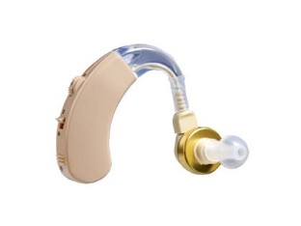
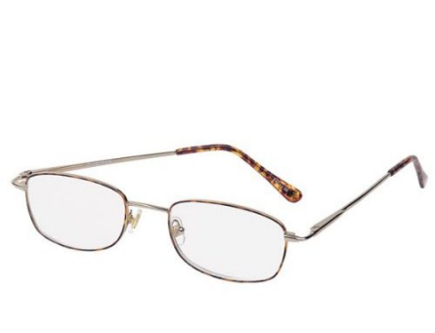
Check dentures, hearing aids and glasses. Are they the right ones? Does the person need them? Are they clean? Is the hearing aid working and at the right volume?

Give lots of cues before the meal so they feel ready to eat and drink.
Give them as much choice as you can. Use picture menus or show them the actual meals to choose from.
Make sure you are comfortable. Sit on a level with the person and opposite them as much as possible so that they are facing the front while they eat and not turning sideways. Stay with them and avoid talking to other people as this is distracting.
Make sure the meal looks appetising. Tell them what it is and what is in each mouthful.
Make sure they can see the food (as able) so they know what it is like and how much is left.
Helping

Support the abilities of the person and let them do as much as they can for themselves. This gives them control and helps the swallow mechanism. Try finger foods if they cannot manage cutlery. If necessary, put cutlery or food in their hand, and guide their hand to their mouth (hand under hand assistance). Sometimes giving them the first taste helps to get them started.

Give lots of verbal prompts but don’t get them to chat whilst eating.

Watch for the swallow to happen. You should be able to see the lump in the front of the neck which is the voice box go up and down in a sort of clunk. If this isn’t visible, listen or feel for a good swallow. This is important as the front of the mouth may look empty when the food is still in the throat, waiting to be swallowed. The food needs to be cleared before you put the next mouthful in, otherwise a build-up in the throat may cause coughing or choking.
The person may need more than one swallow per mouthful. Allow time for this and see if softer food helps. Try placing an empty spoon on their lip or in their mouth to help trigger the extra swallow if necessary. A sip of water after each mouthful is helpful for some people.
Make sure the pace and mouthful size are suitable. Swallowing problems are sometimes completely resolved by taking more time. If the person is eating too fast, try cutting the food smaller, or giving them a smaller spoon or fork. It may be necessary to keep the next mouthful out of reach or sit by them and gently put a hand on their arm to prompt them to wait before loading their mouth. Give verbal prompts if this helps, as they may not realise when their mouth is full.
If they eat very slowly, try using a warming plate to keep food hot, or serving several very small helpings. A long chewing phase may be very tiring, so think about giving smaller meals with snacks in between. Try giving some food in a form that slips down more easily, e.g. yoghurt or custard, but avoid giving pureed diet for all meals unless this has been advised.

Medication

If the person has difficulty swallowing tablets, talk to the GP.
The GP and pharmacist will review the medication. They will decide whether medicine can be given in a different form or stopped.
If the person is refusing medication, the doctor will need to be involved. It is against the law to hide medication in food or drink and give it to the person without their knowledge.
A person with capacity has a right to refuse. If the person refuses and does not have capacity, and medication is considered essential, a Covert Medication Pathway should be followed.
The pharmacist will advise which tablets can be crushed, and whether tablets can be taken with a spoonful of food. Sometimes, a large tablet can be prescribed as two smaller tablets, which might be easier for the person to swallow. Once again, everyone is different. Some people find larger tablets easier. If one tablet is a problem, it does not mean they all have to be changed.
In general, a caplet shape is easier than a round tablet.

Give tablets one at a time.

Some medication can be given in liquid form, but liquid preparations tend to be more expensive and don’t keep so well, so GPs will only prescribe them when it is really necessary. If a person is on thickened drinks, liquid medication may need to be thickened too, and this should be checked with the pharmacist in case the thickening powder affects the medicine. (See page 29 regarding thickeners).

Liquid medication is often given in a little measuring cup which requires the person to tip their head back to drink it. Although you have to measure the dose carefully, it is often better to give it to the person from a spoon so that they can keep their head at a good angle for swallowing.
Medication

Medication can have side effects which influence eating and drinking.
These include:
- Dry mouth (it is very difficult to swallow if your mouth or throat are very dry, however specific medication is sometimes needed to dry excessive saliva too)

- Nausea

- Loss of appetite

- Shaky or weak muscles

- Reduced alertness

- Confusion or hallucinations

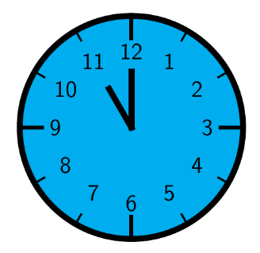
For some conditions, such as Parkinson’s, the timing of medication can be very important.

Swallowing may be better once the dose has had time to work.

If a person starts having swallowing problems, think about whether there has been a recent change in medication and if this could be having an effect.
Reflux
There are many different reasons why people cough. Acid reflux is one of them, and it can make swallowing difficult too.

Acid reflux is common and can irritate the throat.
This may make a person more likely to cough, particularly on certain sharp or spicy foods, or on the first mouthful of a cold drink for example.
Persistent reflux can cause tightness and discomfort in the throat and make swallowing more difficult.
Reflux can be silent, and a person may not be able to tell you if they are experiencing symptoms such as indigestion or heartburn.
Signs to look out for are:
- frequent throat clearing during the day

- coughing at night

- excessive mucus, especially in the morning,

- unusually hoarse voice

- runny nose

- burping

- a sensation of a lump in the throat
Reflux

If these are happening it could be worth discussing this with the GP who may consider whether a double action antacid with an alginate would help. The alginate forms a floating layer over the stomach contents which acts as a barrier to stop bile or acid coming up.

Other things to try are:
- raising the head of the bed

- avoiding tight clothing

- avoiding rich or spicy foods

- avoiding acidic food or drink (eg orange juice, tomatoes)

- avoiding lying down for at least an hour after eating.

If the person can swallow water, sipping water through the day is good for the throat.

Social aspects
Mealtimes are when we eat and drink, but they are also a social time.
For many people they are the key times of day to look forward to, when we chat, share news, and have a laugh.
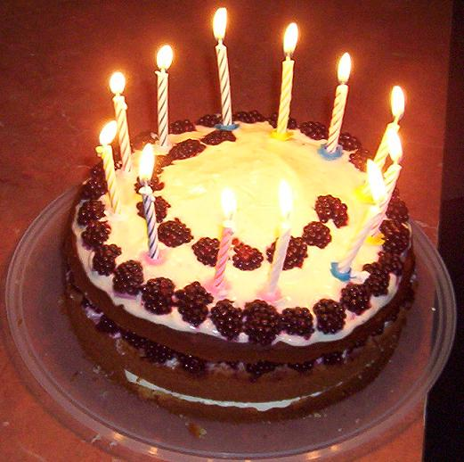
We often celebrate special events with food, and most festivals revolve around traditional meals.

These aspects can be lost for people who have swallowing problems. This can mean they don’t enjoy mealtimes and eat less.

Try to make some time for social interaction before or after the meal. This could involve food preparation or food reminiscence activities which help to motivate the person and interest them in food. It can also help combat “menu fatigue” which is particularly important for people on modified textures.

If a person has any difficulty eating and drinking, they need to concentrate fully on the meal and should not be distracted by chat.

It is important for them not to talk whilst eating and drinking, but for many people, the situation is more relaxed and friendly if there is some conversation.

Think very carefully about your own speech. Try to talk to the person in a way which does not make them laugh or talk during a mouthful.
Social aspects

During the mealtime, if the person is easily distracted, keep your conversation focused on the meal and do not talk about other things.

You may need to give verbal prompts throughout the meal to remind them what is happening and encourage them to eat, but be careful not to ask questions that they will want to answer when their mouth is full! Save questions until they have finished.

Note: asking a question such as “is that nice?” can be a good way to get the person to vocalise so you can hear whether their mouth and throat are clear and ready for the next mouthful. Only do this after you think they have swallowed.

Interaction is important even if the person has very limited language. Familiarise yourself with what they understand and how they express their needs and feelings. Is there a reliable way for them to indicate Yes and No? Allow the time they need to process what you say, keep speech simple and use visual cues. Remember that the sound of your voice and your manners will be meaningful even if the words themselves are not fully understood.

It is important to try to make sure people who have to eat modified textures do not feel excluded or different. Aim to make their mealtime experience as much like what they are used to as you can.

If food needs to be cut up or mashed, do this before the meal is served so the person does not feel patronised.

Texture
Changes in sensation, reduced muscle strength and movement, poor dentition, ill-fitting dentures, or discomfort in the mouth can all make chewing difficult.
This can result in:
- Holding food in the mouth and not swallowing
- Taking a long time to chew each mouthful
- Bits of food left in the mouth after swallowing
- An increased risk of coughing, choking or silent aspiration
- Spitting bits out
- Getting too tired to finish the meal

The foods which are most difficult to chew and swallow are:
- Dry crumbs or flakes, rice unless very soft and in a sauce
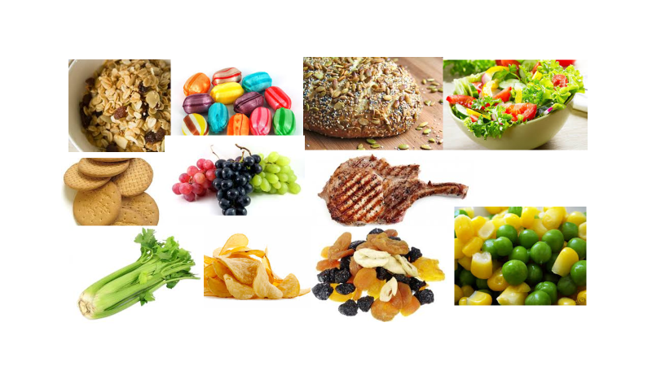
- Pips, seeds and husks
High-Risk Foods
- Hard or chewy lumps, including dried fruit
- Bits, strings and skins
- Floppy leaves such as cabbage or lettuce, most salad
- Crisps (starch based snacks are better as they break down in the mouth.)

If you notice the person has problems, try avoiding these high-risk foods.
Try adding thick sauce or gravy which helps the food hold together.

Don’t puree all the meals unless this has been advised. Some people need puree after an illness, but then get better. If chewing has recovered, you may be able to try more textured food. This should be done in small stages.
Texture

Keep records of what the person finds easiest. Everyone is different. People may manage quite different textures with different types of food.

Some people find mashed potato sticky and difficult, or scrambled egg too bitty even though it is soft.

Bread can be cloying, but chips are often managed well.

Biscuits vary: some stay very dry and crumbly in the mouth, but others dissolve down to a pulp.

Food which has a mixture of liquid and solid bits, such as muesli, broth, or mince in a thin gravy, can be hard to manage. Try blending soup, thickening gravy, and serving porridge or wheat biscs instead of more bitty cereals.

If the person is coughing on liquids, think about their head position and the shape of the cup. Are they better with a wider cup or a straw so that they keep their chin level while drinking?

Thickeners should be avoided unless absolutely necessary and should only be used on the advice of an SLT. They can cause dehydration and constipation and may not reduce the risk of chest infections. Try other strategies. A sharp flavour like sour lemon, carbonated drinks, or ice-cold temperature might help to trigger the swallow.

If the person has been advised to use thickener, make sure it is not too thick. Follow the instructions carefully and allow enough time for the mixture to thicken before giving it to the person. Also be aware that drinks tend to thicken further when left standing for a long time, so it is important to make fresh drinks regularly.
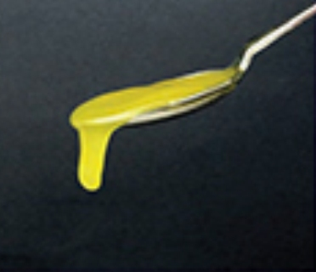
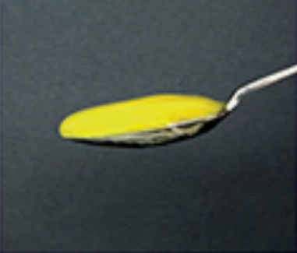
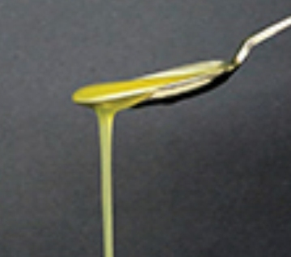
Naturally thick
Eg Smoothie
Milk shake

Level 1 slightly thick Level 2 mildly thick Level 3 moderately thick Level 4 extremely thick
As with puree, if the person is recovering from a temporary illness, they may not need to stay on thickener long term.
Preferences

It is very important to find out as much as you can about the person. Speak to family and friends, check records, give appropriate choices and note what works well.
Know what they like to eat, and when, and what environment suits them.

Observe cultural or ideological preferences. Check for allergies.
Kosher? Ramadan? Vegetarian? Halal? Vegan? Pescetarian?

Find out what interests the person, and what activities they enjoy during the day, as happy, motivated people eat better.

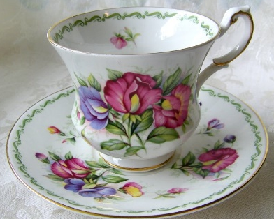

Try to find out what kind of cup or glass they always liked to use in the past. It may not be possible to use their favourite mug, but if they are having difficulties, using familiar items may help.

Preferences
Offer visual choices using picture menus, or show the actual meal.

Make sure choices refer to the meal which is going to be eaten next. It is confusing if there is a different meal in between.

Remember that tastes may change, so keep good records of this.
Experiment with different flavours if you think tastes are changing. This can happen suddenly so don’t assume if something was enjoyed yesterday it will still be a favourite tomorrow.

If a person cannot speak, their eating habits may be a way of communicating.
For example, closing their mouth or holding food in their mouth may be a way of telling you they do not like the meal, although it could also indicate a swallowing problem.

It is important to use verbal and other prompts to remind them what the food is, as they may not recognise the flavour.

If they aren’t able to tell you, use your observations to work out whether they like the food. Remember a variety of tastes and textures stimulates the senses, and the noise and feel of food in the mouth can be important as well as the taste. Perhaps they have been eating softer foods and miss the crackle and crunch. Are there some crunchy foods they can manage, such as starch based snacks? (see page 28)

Portion size can be a significant factor. A large portion may put a person off, so be aware of their preferences as to how the meal is served.

People with dementia often develop a taste for sweeter food and may not enjoy the savoury dishes. This is because the sensory messages to the brain have changed, and they cannot detect flavours and smells as they used to.
If they are refusing savoury food, try adding sweet sauces such as chutney, ketchup or honey, and using naturally sweet vegetables such as carrots, sweet potato, peppers or beetroot.

Remember that even when the SLT has advised softer textures for some foods there will normally be exceptions, and favourite foods are often eaten better.

Rights and risks
The person has a right to quality of life as well as a right to safe and effective care. We tend to think of safety as the critical issue, but this can sometimes mean that other aspects of the person’s well-being are not taken into account.
Safety is important. People with advanced dementia often have a swallowing difficulty, and this increases the chance of food or drink going in to the airway and causing choking or chest infections.

In many cases a Speech and Language Therapist will do an assessment and make recommendations to reduce the risk. The advice may involve changing positioning, or the way food is served or fed to the person, or, if necessary, modifying food consistencies.

Sometimes the person does not want to follow the advice or finds the modified food unappetising.
This is always a difficult situation because you do not want to increase the likelihood of choking or chest infections.

As well as the risk of infection, we must consider the risk of poor nutrition or hydration due to the person not eating enough if they don’t like thickener or soft food.
We must also take in to account that choosing to eat foods they enjoy, in spite of a risk, may improve the person’s quality of life.

When a person has capacity, we can explain the likely consequences of different options, and allow them to make a choice.

If they do not have capacity, we must still make every effort to respect their wishes, as well as the judgement of the person legally nominated to act for them. The law says our intervention must restrict the person as little as possible, so we should only suggest changes we consider necessary.

Rights and risks

These can be difficult decisions.
Work is being done on ways to balance the different risks associated with eating and drinking. It is important to remember that although the SLT advice may reduce the risk of aspiration, sometimes there are other significant factors.
Evidence shows that poor mouth care is a bigger cause of chest infections than a poor swallow.
The SLT assessment is only part of a wider picture, including your knowledge of the person’s own wishes, their eating history and how successfully they are already compensating for any difficulties. Input from the whole multi-disciplinary team is very important. Sometimes, even after full assessment and consultation, we are balancing probabilities and cannot be 100% sure what will help.
Occasionally we give advice as a trial, to see if there is benefit.
Other key factors include the person’s alertness, mood, interest in the food, distractibility, positioning, mouth care, medication and general health.
The skill and support of the person assisting them can make a huge difference too.
It could be that these additional factors are just as important as keeping rigidly to the texture recommendations. Following these other aspects of the advice may sometimes be what achieves the best results.
Sometimes the SLT does not have any advice to offer which will improve the person’s well-being.
There are times when there is no option but to give a person food and drink even though there is a significant risk of aspiration. This can be stressful for you as the carer as well as for the person who has difficulty swallowing. Food and drink must be offered if the person needs it.
In these situations, it is important to understand the views of all the people involved so that a care plan can be developed which is in the best interest of the person in terms of their quality of life as well as their safety.
Cognition
It is important to remember that the person with dementia still thinks about things, and this may affect their eating and drinking.
For example, if they are holding food in their mouth, it may be because they are thinking it is not the food they chose or expected.

They might refuse food because they think they need to pay for it and are worried they have not got the money.

They might eat too fast because they think that is the only meal they will get or worry that the food will be taken away.

They might not eat because something distracts them or frightens them and makes them think they are in a different environment.

They might be worrying about an appointment or a visit, or maybe something that has happened earlier that day.

They may not understand what is difficult or risky and have no idea why it is important to avoid certain foods.

They might want to give their food to somebody else because they are thinking of someone they looked after in the past.

They may take another person’s food without any awareness that it is not theirs or put non-food items in to their mouth because they are hungry and do not recognise what they see.

They might feel ashamed or embarrassed or worry about being a nuisance.
Cognition

You may be able to reassure the person with patient verbal explanations, but sometimes they will not understand.
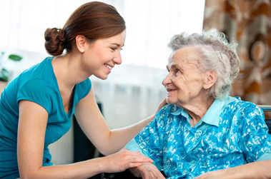

Try to see the world through their eyes and work out how to resolve the specific issues, through positioning, environment, non-verbal cues and modelling.

Once again, keeping records is very important so you can see what leads up to particular thoughts or behaviours, and build on the positive routines.

The person may need constant supervision at mealtimes, even if they do not have a swallowing problem.

- Reflection
Write about three things you have learnt.
What difference will this make to the people in your care?

Links
Manual for Mealtimes
https://services.nhslothian.scot/carehomes/wp-content/uploads/sites/31/2023/10/Manual-for-Mealtimes-in-Care-Homes.pdf
Supporting people with eating, drinking and swallowing using the Manual for Mealtimes on Vimeo

https://www.rcslt.org/members/clinical-guidance/dementia/

