**CPL 2025 Protection**

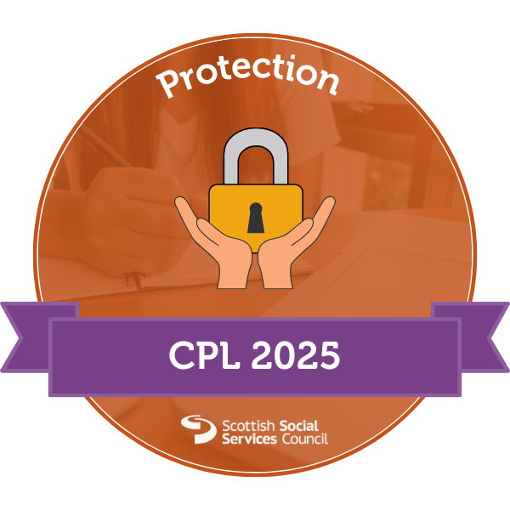This badge is awarded to SSSC registrants who successfully record any learning activity relating to the protection core learning element of their Continuous Professional Learning (CPL).

Introduction

[Note: This badge is intended for SSSC registrants on the Social Care and Children and Young People Workforce part of the Register.]

This Open Badge recognises SSSC registrants who have demonstrated a commitment to developing their skills in the crucial area of protection within the social care and children and young people workforce. This badge focuses on one of the seven core learning elements of Continuous Professional Learning (CPL).

While this badge is not a mandatory part of your CPL requirements, it offers several benefits for those who choose to pursue it.

* Recognition of your extra effort: This badge acknowledges your dedication to going above and beyond in your professional development.
* Tangible proof of learning: It provides concrete evidence of your learning in communication and relationships, which you can showcase to employers, colleagues, and service users.
* Reflection and growth: The process of earning this badge encourages deeper reflection on your learning, helping you to better integrate new knowledge into your practice.
* Career development: Demonstrating your commitment to ongoing learning can support your career progression and professional goals.
* Improved services: By focusing on rights based and ethical practice, you're investing in skills directly impacting the quality of care you provide.

By pursuing this badge, you're not just fulfilling CPL requirements, but actively engaging in a programme of open recognition that values lifelong learning and continuous improvement in the social care sector.

You can apply for this badge once per year. If you need to record further learning under the same core learning element within the same year, you can apply for a CPL+ badge.

Criteria

To achieve this badge you must:

* put your SSSC registration number, register part and name of your employer at the top of your evidence submission (**Required**)
* tell us about the topic and learning activity you have chosen (**50 words minimum**)
* explain why this learning activity is relevant to your development under the protection core learning element of your CPL (**25 words minimum**)
* tell us about three things you learned and why each of these is important to (a) you and (b) people who use your service (**150 words minimum**)
* explain how you will apply what you've learned to improve the quality of care or support you provide in your day-to-day work (**150 words minimum**)
* reflect on how this learning experience has increased your confidence (**75 words minimum**).

There is a maximum word count for this badge of 750 words.

To help write your submission, you can download a [template with these questions](https://www.badges.sssc.uk.com/wp-content/uploads/2023/04/challenge-template.odt) in Open Document Format (ODT) and open it in a word processor like Microsoft Word, Open Office or Apple Pages.

Your application will be returned to you with a request for further evidence if it does not meet all the above criteria or is unclear which of these questions you are answering within your evidence.

Prerequisites

You must successfully achieve the Introduction to SSSC CPL badge before applying for this one.

You must also be registered with the Scottish Social Services Council under the Social Care and Children and Young People Workforce part of the Register at the time of your application.

Evidence

You will need to submit a written statement of at least 450 but no more than 750 words in response to the questions asked in the criteria. You can write your statement directly on the badge application form or paste a link to your own blog or portfolio.

When preparing your evidence, consider the following guidance for each question.

Topic and learning activity (50 words minimum)

* Be specific about the protection topic you focused on (e.g., child protection, adult protection, safeguarding practices).
* Describe the format of your learning (e.g., workshop, online course, shadowing, reflection on practice etc).
* Mention any resources or materials you used during this learning activity.

Relevance to CPL (25 words minimum)

* Connect the learning to your current role or future career aspirations in relation to protection.
* Consider how this learning addresses any gaps in your knowledge or skills about protecting individuals from harm or abuse.
* Reflect on how this learning aligns with the protection needs of the individuals you support.

Three key learnings (150 words minimum)

* Be specific about each learning point related to protection, avoiding vague statements.
* For each point, explain its relevance to your professional practice in safeguarding individuals.
* Describe how each learning point can directly benefit the safety and protection of the individuals you support.
* Consider both immediate and long-term impacts of applying this learning to enhance protection measures.

Applying learning to improve care (150 words minimum)

* Provide concrete examples of how you'll implement your learning about protection in your role.
* Describe any changes you plan to make in your approaches to safeguarding and protecting individuals from harm or abuse.
* Explain how these changes will lead to better protection outcomes for the people you support.
* Consider any potential challenges in applying your learning about protection, and how you'll address them.

Reflection on increased confidence (75 words minimum):

* Describe how this learning has enhanced your understanding of protection in your role.
* Explain how this new knowledge or skill makes you feel more prepared to safeguard individuals and respond to protection concerns.
* Reflect on any aspects of protection in your work that you now feel more capable of handling.
* Consider how this increased confidence might positively impact your ability to protect people who use your service and collaborate with colleagues on safeguarding matters.

We will also accept an audio or video submission if you prefer.

The evidence you submit will be viewable by anyone who you show your badge to. Do not include confidential or private information within your submission.

Terms and conditions

I confirm that I have already achieved the Introduction to SSSC CPL badge. I have read, understood and completed all the activities listed in the badge criteria and each question from the criteria is answered in the evidence I have provided. My evidence has been written or recorded by me and I have not copied it from anywhere else or used an AI tool to produce it. I understand that it will take 28 days for you to assess my application and that feedback cannot always be provided if it is unsuccessful.